Task 1:
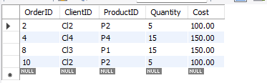
Query:
SELECT * FROM Orders
WHERE Cost <= 250;

Task2:
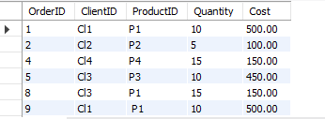
Query:
SELECT * FROM Orders
WHERE Cost BETWEEN 50 AND 750;

Task3:
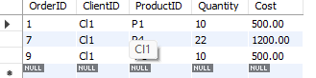
Query
SELECT * FROM Orders
WHERE ClientID = "Cl1" AND Cost > 100;

Task4:
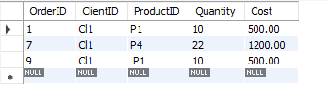
Query:
SELECT * FROM Orders
Where ClientID = "CL1" OR "CL2" AND (Quantity > 2);

Task5:
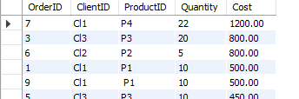
Query:
Select * FROM Orders
ORDER BY Cost desc;

Task6:
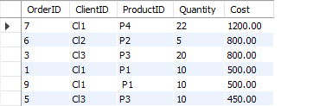
Query:
select * from Orders
Order by Cost desc,ClientID asc;

Task7:
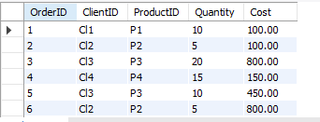
Query:
update Orders Set Cost = 100
Where OrderId = 01;

